Project Planning Phase
Project Planning Template (Product Backlog, Sprint Planning, Stories, Story points)

Date | 15 February 2026
Team ID | LTVIP2026TMIDS24256
Project Name | Heritage Treasures: An In-Depth Analysis of UNESCO World Heritage Sites in Tableau
Maximum Marks | 5 Marks

Product Backlog and Sprint Schedule (4 Marks)
Sprint-1 (Data Collection & Preparation)
Use the below template to create product backlog and sprint schedule
Sprint | Functional Requirement (Epic) | User Story Number | User Story / Task | Story Points | Priority | Team Members
Sprint-1 | Data collection (epic -1) | USN-1 | Gathering UNESCO Dataset from Kaggle | 2 | High | Battula Bala Sai
Sprint-1 |  | USN-2 | Loading Data into Tableau | 1 | High | Dhanunjay Prabhakar Mugata
Sprint-1 | Data preparation(Epic - 2) | USN-3 | Handling Missing Values | 3 | High | Immaneni Karthik
Sprint-1 |  | USN-4 | Creating Calculated Fields | 3 | High | Jakkula Kavya
Sprint-1 |  | USN-5 | Handling data inconsistencies | 3 | High | Battula Bala Sai

Total Story Points in Sprint-1 = 12
Sprint-2 (Visualization, Dashboard & Story)

Sprint | Functional requirement (Epic) | User story number | User story/ task | Story points | Priority | Team Members
Sprint-2 | Data visualization (Epic - 3) | USN-6 | Create Bar Chart | 2 | High | Dhanunjay Prabhakar Mugata
Sprint-2 |  | USN-7 | Create Pie Chart | 2 | High | Jakkula Kavya
Sprint-2 |  | USN-8 | Create Line Chart | 2 | High | Immaneni Karthik
Sprint-2 |  | USN-9 | Create Map Visualization | 4 | Medium | Battula Bala Sai
Sprint-2 | Dashboard(Epic-4) | USN-10 | Develop interactive dashboard | 5 | High | Team collaboration
Sprint-2 | Story (Epic-5) | USN-11 | Develop Tableau story | 5 | Medium | Team collaboration

Total Story Points in Sprint-2 = 20

Total Story Points & Velocity
Total Story Points:
Sprint-1 = 12
Sprint-2 = 20
Total = 32 Story Points
Number of Sprints = 2
Velocity Formula:
Velocity = Total Story Points Completed / Number of Sprints
Velocity = 32 / 2
Team Velocity = 16 Story Points per Sprint
This means the team can complete 16 Story Points in one sprint on average.
Project Tracker, Velocity & Burndown Chart
Sprint Tracking Table

Sprint | Total Story Points | Duration | Sprint Start Date | Sprint End Date (Planned) | Story Points Completed (as on Planned End Date) | Sprint Release Date (Actual)
Sprint-1 | 12 | 6 Days | 24 January 2026 | 29 January 2026 | 12 | 29 January 2026
Sprint-2 | 20 | 8 Days | 31 January 2026 | 05 February 2026 | 20 | 05 February 2026

Velocity:
Imagine we have a 10-day sprint duration, and the velocity of the team is 20 (points per sprint). Let’s calculate the team’s average velocity (AV) per iteration unit (story points per day)

Assume Sprint Duration = 8 Days
Sprint Velocity = 16 Story Points
Average Velocity Per Day (AV)
AV = 16 / 8
AV = 2 Story Points per Day
So, the team completes approximately 2 story points per day.
Burndown Chart:
A burn down chart is a graphical representation of work left to do versus time. It is often used in agile software development methodologies such as Scrum. However, burn down charts can be applied to any project containing measurable progress over time.

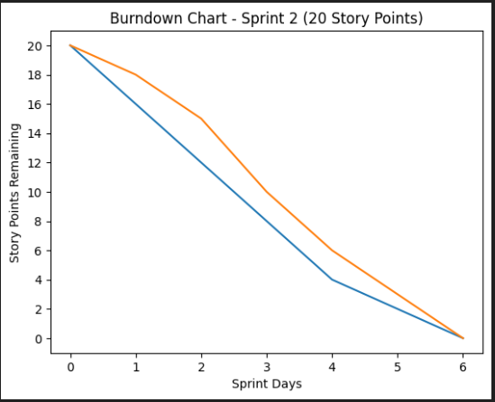

https://www.visual-paradigm.com/scrum/scrum-burndown-chart/
https://www.atlassian.com/agile/tutorials/burndown-charts

Reference:
https://www.atlassian.com/agile/project-management
https://www.atlassian.com/agile/tutorials/how-to-do-scrum-with-jira-software
https://www.atlassian.com/agile/tutorials/epics
https://www.atlassian.com/agile/tutorials/sprints
https://www.atlassian.com/agile/project-management/estimation
https://www.atlassian.com/agile/tutorials/burndown-charts

